Fernando Marquez

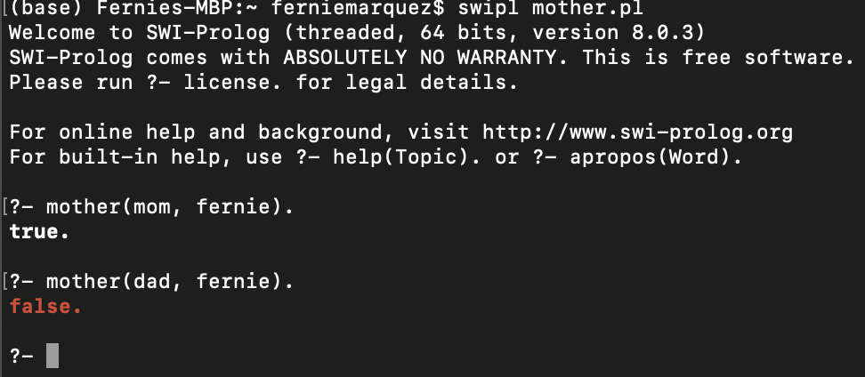

Mother.pl

female(mom).

parent(dad, fernie).

parent(mom, fernie).

mother(X,Y) :- parent(X,Y), female(X).

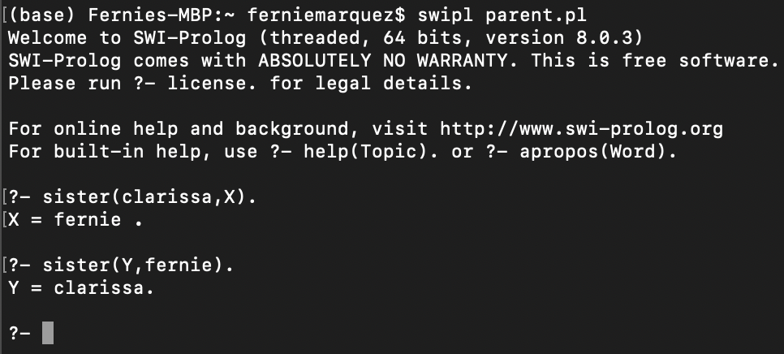

Parent.pl

parent(fernando, fernie).

parent(fernando, clarissa).

male(fernie).

male(fernando).

female(clarissa).

sister(X,Y) :- parent(Z,X),parent(Z,Y), female(X), X \==Y.

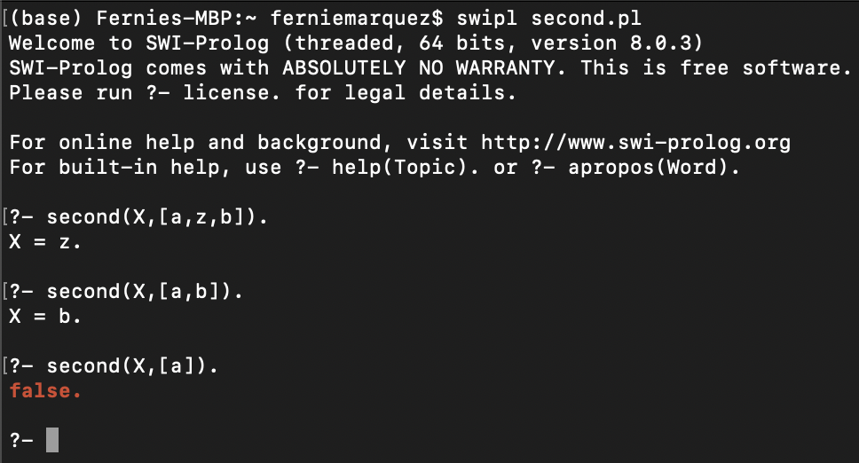

Second.pl

second(X,[_,X|List]).

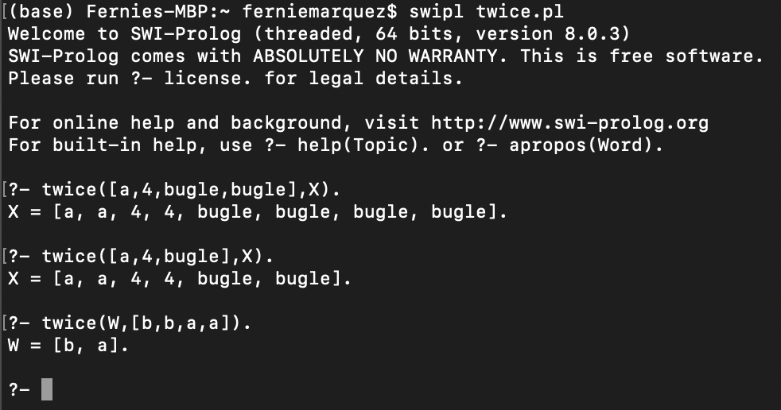

Twice.pl

twice([ ], [ ]).

twice([X|Y], [X,X|Z]) :- twice(Y,Z).

Interleave.pl

interleave([ ],[ ],[ ]).

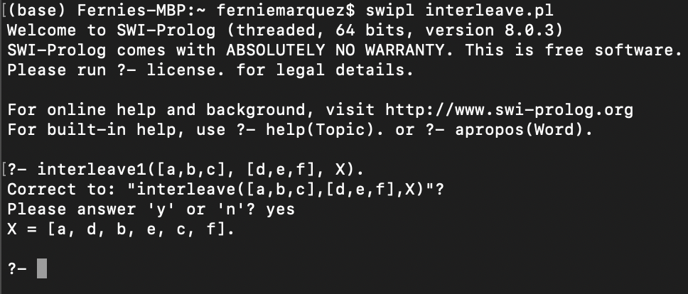interleave([X|Y], [W|Z], [X,W|R]):- interleave(Y,Z,R).